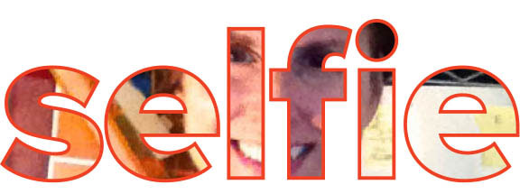

Dear Parent(s) and/or Guardian(s), 10/01/14

Your child has the opportunity to participate in this year’s themed exhibit with the HCPSS in partnership with the Columbia Arts Center. The theme this year is “Art of the Selfie.” Participation in this activity is completely voluntary. If your child chooses to participate please consider the following.

The theme is based on something that has become trite in society today. Student images should document and showcase different personal perspectives and originality. Extensive conversations will take place with the children in the intermediate grades. However, this is a little more difficult to discuss in the primary grades. That doesn’t mean that primary students cannot participate. If you need more guidance, please check the following link, and scroll toward the bottom of that particular page. http://artatcces.weebly.com/community-exhibitions.html

Please bear in mind that all images are to be student generated using technology from the home. There really can’t be any assistance by an adult beyond that of a technical nature. This also means that your child will use some sort of camera, camera phone, table, etc. that is not owned by the HCPSS. Thus, HCPSS cannot be libel in case of damage or loss. The understanding is that this will not interrupt the flow of instruction during the student day, so please make sure pictures are taken outside of the school day. However, students can take pictures before school, on the way to school, outside of the school building, after school, etc.

If your child chooses to participate, he/she may not be in the final show. Only a handful of submissions will be chosen from each school. The images your child takes that day will have to be downloaded and then emailed to me (mailto:benjamin_schmitt@hcpss.org) by Friday, 11/14. Prior to emailing them, please check for things like focus, strength of image, etc. You and your child will be notified if they will be taking part in the county exhibit. It will take place at the Columbia Arts Center, January 7th through February 2nd.
Thank you so much for taking part in this exciting new activity. Feel free to contact me with any questions.

Artfully,
Benjamin Schmitt
Art Teacher

